CTD Watch Standing Report: by James Hooper

The CTD watch consists of monitoring and recording the real-time data depth profiles of the full water column as well as collecting water samples at predetermined depths. This is done with a package known as the CTD rosette. This consists of Niskin bottles attached to a cylindrical frame, which are designed with lids at both ends that are electronically triggered allowing for the sampling of individual parcels of water at different depths. Along with the Niskins, various electronic instruments are mounted on the frame of the rosette. These include a CTD, which records the salinity (via conductivity), temperature, depth (via pressure), as well as oxygen and density. Also attached is LADCP (lowered acoustic Doppler current profiler), which measures the currents by determining the Doppler shift of particulate in the water column. Also attached is a fluorometer to measure the fluorescence as an indicator of the biomass and an altimeter with allows profiles down to within 10 meters of the bottom of the sea floor.

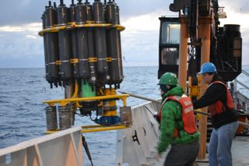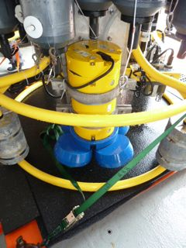
CTD rosette being recovered (left) and a close up of ADCP as well as the CTD sensors (right).

Along with the CTD profiles done at each station, drifters and floats are also released throughout the cruise. They are equipped with GPS and use the ARGOS satellites to transfer the data back to land. The drifters allow for tracking the surface currents. The floats are designed to sink to a specific pressure traveling with subsurface currents while taking CTD profiles and returning to the surface periodically to upload the data. Both the drifters and the floats allow for continuous monitoring well after the cruise is complete.

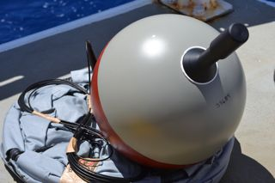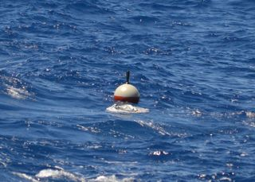
Drifter on deck before deployment (left) and drifter deployed (right). Below is a diagram of how the float operates once deployed.

